**DAILY ONLINE ACTIVITIES SUMMARY**

|  |  |  |  |  |  |  |  |  |
| --- | --- | --- | --- | --- | --- | --- | --- | --- |
| **Date:** | **22/05/2020** | | | | | **Name:** | **Shwetha** | |
| **Sem & Sec** | **8th B** | | | | | **USN:** | **4AL16CS101** | |
| **Online Test Summary** | | | | | | | | |
| **Subject** | | **BDA** | | | | | | |
| **Max. Marks** | | **40** | | **Score** | | | **29** | |
| **Certification Course Summary** | | | | | | | | |
| **Course** | **Ethical hacking** | | | | | | | |
| **Certificate Provider** | | | **Great learning** | | **Duration** | | | **6hr** |
| **Coding Challenges** | | | | | | | | |
| **Problem Statement:**  **prob1: write a program to rotate the array to the right by k steps where k is a nonnegative** | | | | | | | | |
| **Status: Solved**  **Solution link: https://github.com/alvas-education-foundation/Shwetha-** | | | | | | | | |
| **Uploaded the report in Github** | | | | | **Yes** | | | |
| **If yes Repository name** | | | | | **Shwetha-** | | | |
| **Uploaded the report in slack** | | | | | **Yes** | | | |

Online Test Details:

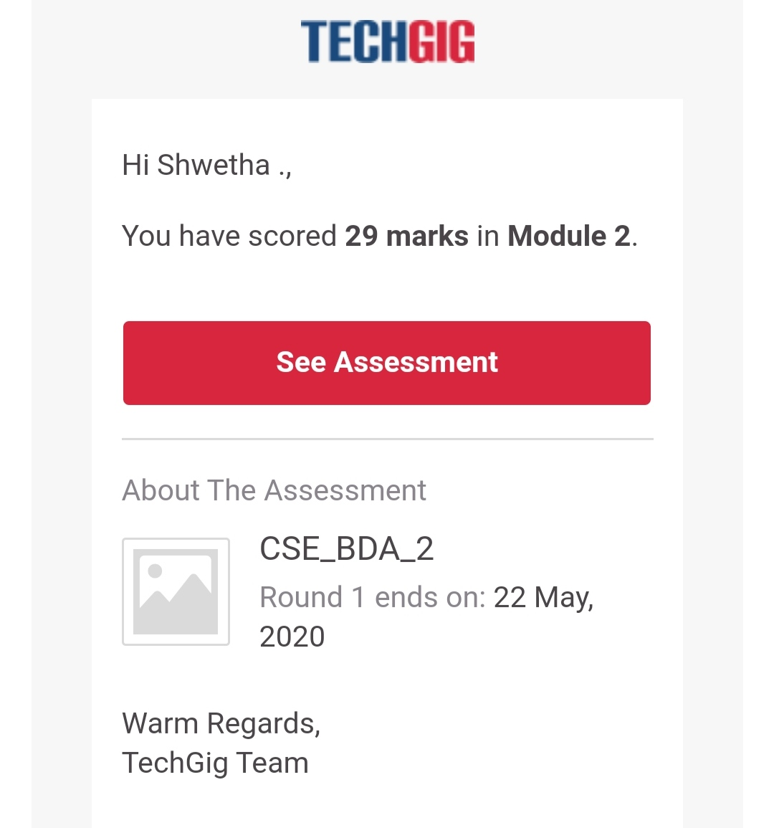

Certification Course Details:

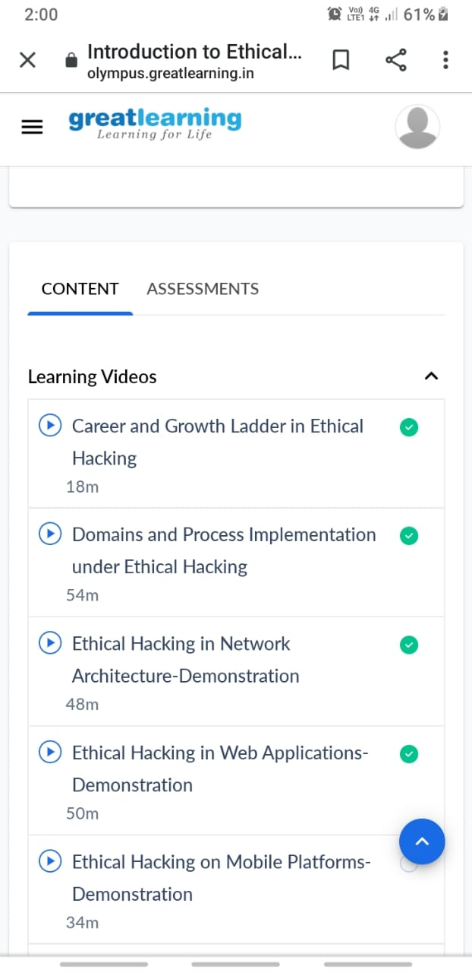

Coding Challenges Details:

Program 1:

#include <stdio.h>

void rightRotate(int A[], int k, int n)

{

int aux[k];

for (int i = 0; i < k; i++)

aux[i] = A[n-k+i];

for (int i = n-k-1; i >= 0; i--)

A[i+k] = A[i];

for (int i = 0; i < k; i++)

A[i] = aux[i];

}

int main(void)

{

int A[] = { -1,-100,3,99 };

int k = 2;

int n = sizeof(A)/sizeof(A[0]);

rightRotate(A, k, n);

for (int i = 0; i < n; i++)

printf("%d ", A[i]);

return 0;

}